Introductions:
The mitre.org is a huge framework that has the main purpose is that to safe this digital world.
Following are the frameworks of the mitre:
ATT&CK (stand for adversarial Tactics, Techniques, and Common Knowledge) Framework
CAR (Cyber Analyst Repository) Knowledge Base.
ENGAGE.
D3FEND (detection, Denial, and Disruption Framework, Empowering , Network Defense)
AEP: (Att&ck emulation plan):
In MITRE D3FEND: gives the useful information for the every types of attack and its modifications.
For example: in the Mostly the network firmware could be analyzed actually that these firmware are tampered or modified and surface the attack vector for the attacks.
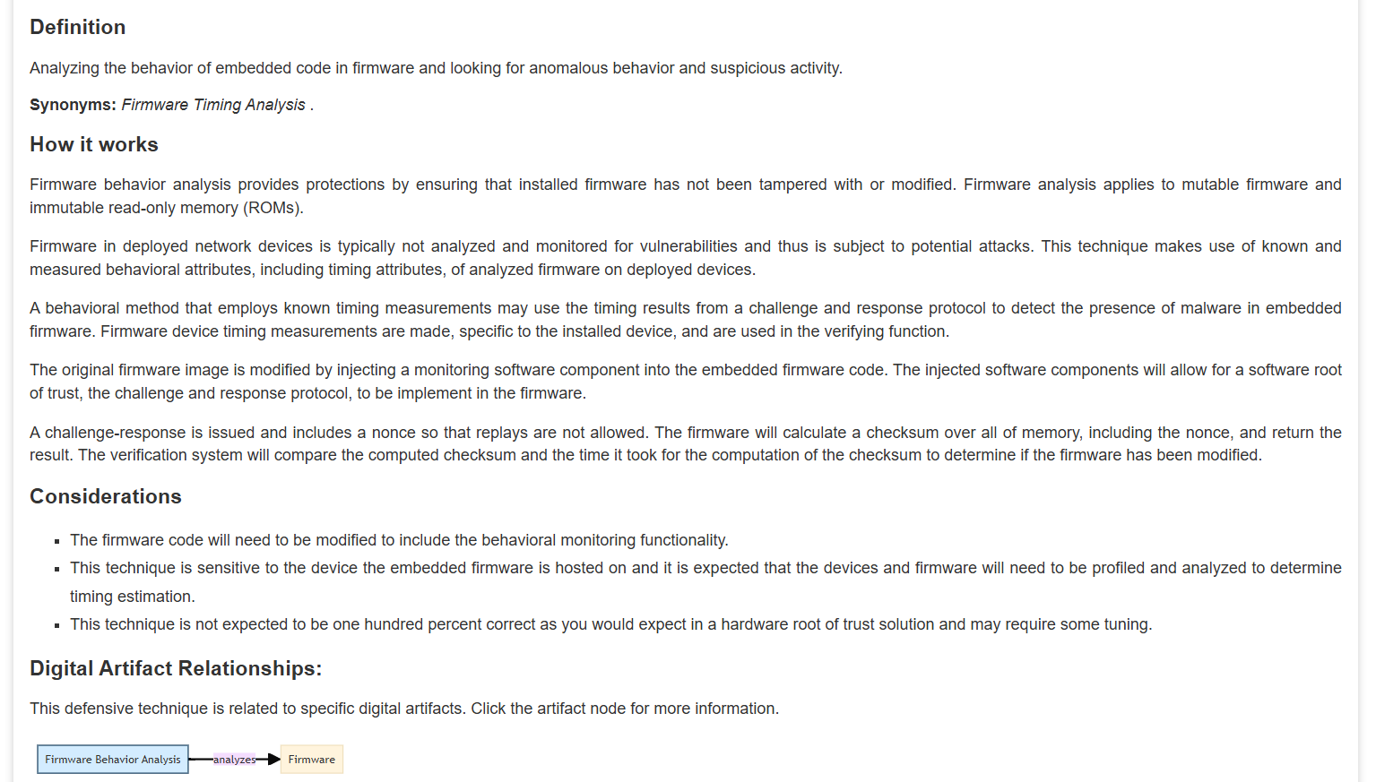

Firmware device timing measurements are made, specific to the installed device and are used in the verifying functions.

We can analyzed the firmware by the speed(time) and response to spot that any thing unsusal.

Let’s break firmware and firmware behavior analysis into simple words and then look at real-life examples so it’s easy to understand:

🔹 What is Firmware?
- Firmware is software that lives inside hardware devices and controls how they work.
- It sits between the hardware and the normal software/OS.
- Unlike regular apps you can easily update, firmware is often hidden and stored in special chips inside devices.
✅ Everyday examples of firmware:
- Wi-Fi router: The small program inside it that controls internet routing.
- Laptop BIOS/UEFI: The code that runs before Windows/Linux even starts.
- Smartphone baseband: The program inside your phone’s modem that talks to cell towers.
- Printer: The code that controls printing instructions.
- Smart TV / IoT devices: Code inside a smart bulb or camera that makes it “smart.”
Think of firmware as the brain of the device—it tells the hardware how to behave.

🔹 What is Firmware Behavior Analysis?
It’s a security check to make sure the firmware hasn’t been hacked or secretly changed.
- Instead of only looking at the code, it also watches how the firmware behaves—like its speed (timing) or responses—to spot anything unusual.
Imagine you know your friend always takes 5 seconds to solve a specific math problem.
If one day they take 10 seconds, you might suspect something is wrong.
Firmware analysis does something similar with timing measurements.

🔹 How it Works (Simple Steps)
- Profiling – First, the normal firmware is measured:
  - How long it takes to answer a specific challenge.
  - How it computes a checksum (a kind of digital fingerprint).
- Challenge-Response Test – A verifier sends a challenge (like a random number).
- The firmware must:
  - Calculate a checksum of its memory including the random number.
  - Send the result within an expected time.
- The verifier checks:
  - Is the checksum correct? ✅
  - Did it respond within the usual time? ⏳
If it’s slower, it might mean extra malicious code was added.

🔹 Practical Real-World Scenarios

🖥️ 1. Laptop BIOS/UEFI Protection
- Scenario: A hacker installs a rootkit inside your BIOS so it stays even after reinstalling Windows.
- Analysis: Your security system sends a random challenge.
- If the BIOS was altered, it might take longer to calculate the checksum because of extra malicious instructions → ⚠️ Alert!

🌐 2. Router Firmware Attack
- Scenario: An ISP router is infected with malware that secretly sends your data to attackers.
- Analysis: Network monitoring software challenges the router’s firmware.
- The infected firmware struggles to respond in the expected timing → The ISP flags the router for replacement.

📱 3. IoT Camera Security
- Scenario: A hacker modifies the firmware of a smart camera to spy on you.
- Analysis: The challenge-response protocol detects an unusual delay when the camera verifies its memory → The camera is quarantined.

🔹 Key Takeaways
✅ Firmware is like the invisible operating system of your hardware.
✅ Firmware behavior analysis is like a health check for that invisible system.
✅ It doesn’t just read the firmware—it measures how it behaves, especially timing.
✅ Useful when direct code inspection is hard (like sealed IoT devices).

Would you like me to show a mini practical example in Python of a simple challenge-response timing check (simulating firmware)?

Basic Terminology:
Following terminologies are used frequently i.e.:
  - APT: Advanced persistence threat (do not afraid with the term APT i.e. not all the APT’s have the zero-day exploits most of the APTs used commons techniques)
  - TTP: (stand for the tactics, technique and procedure) actually that these are methodologies that the attacker used.
Tactic: is the goal of the adversary.
Technique: how the adversary achieves the goal.
Procedure: how is the technique is used.

Att&ck framework: (stand for adversarial tactics, techniques and common knowledge framework):
this is MITRE framework is gold mine for understanding the TTPs of the simple attacks to APTs level
It provides us the 14 categories from simple phishing to advanced level.
In the initial Access there are 9 techniques each techniques also have sub-categories that help us to understand the attack methodology and remediate it

The MITRE attack is very useful for the blue and red teamer as well.
In the MITRE navigator: we have the 3 sections selection
controls, layer controls and technique controls.
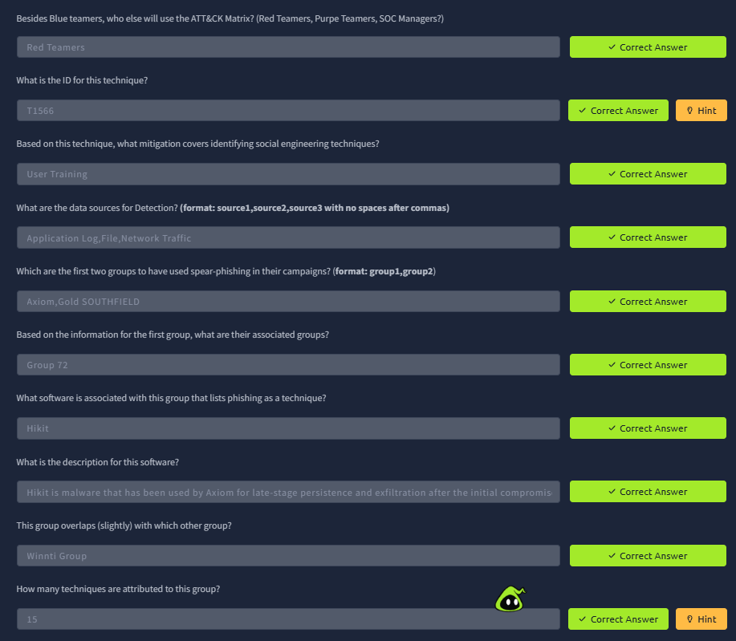

CAR analyst:
Cyber analyst Repository gives the analyzed reports on the different attacks and also gives us the query to search and made a strategy against these attacks.
Specially on the Splunk through Sysmon and EQL ( Event Query language)
EQL is used to query , parse and organize Sysmon event data.
To summarize, CAR is a great place for finding analytics that takes us further than the Mitigation and Detection summaries in the ATT&CK ® framework. This tool is not a replacement for ATT&CK ® but an added resource.

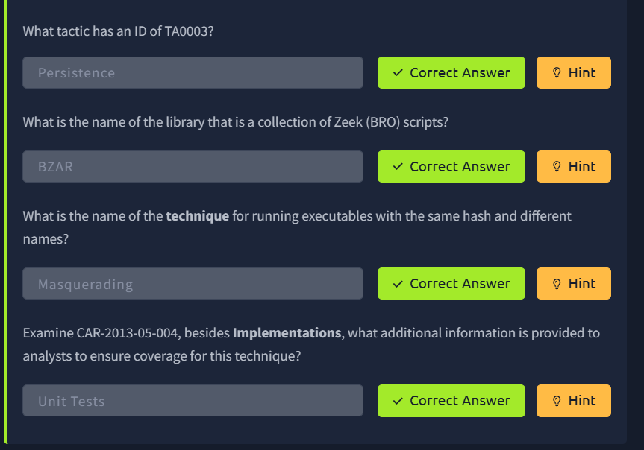

MITRE Engage:
In the MITRE engage we can discuss the procedure and planning to engage our adversary to learn from its TTPS and establish a well security procedure.
This is also known as an adversary engagement approach.
Here we used the 2 methods cyber denial and cyber-Deceptions.
Cyber Denial: In the Cyber Denial we disrupt the adversary operations.
Cyber-Deceptions: in these techniques we give some artifacts controlled according to our choice to adversary to trap the adversary this is a concept of the Honey-port and T-port.

Often we used the cyber denial and cyber deceptions to make a strategic plan about the adversary engagement.
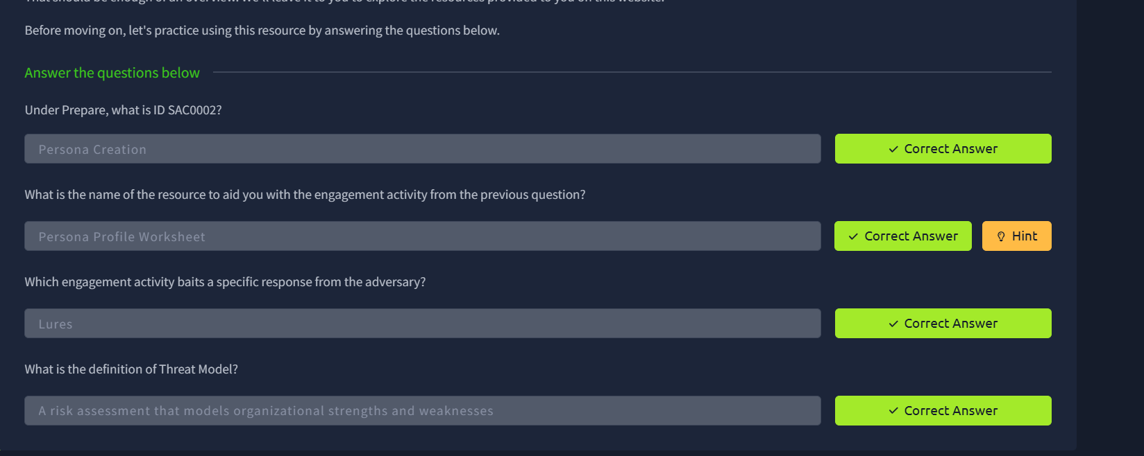

Mitre D3FEND:
This framework of the mitre gives the knowledge graph of strategies to counter measure cybersecurity threats.
D3FEND stands for D etection, D enial, and D isruption F ramework E mpowering N etwork D efense.

As you can see, you're provided with information on what is the technique ( definition ), how the technique works ( how it works ), things to think about when implementing the technique ( considerations ), and how to utilize the technique ( example ).
Note, as with other MITRE resources, you can filter based on the ATT&CK matrix.
Since this resource is in beta and will change significantly in future releases, we won't spend that much time on D3FEND.
The objective of this task is to make you aware of this MITRE resource and hopefully you'll keep an eye on it as it matures in the future.
We will still encourage you to navigate the website a bit by answering the questions below.

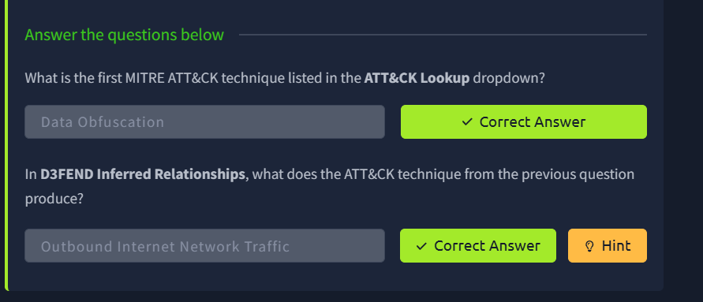

Att&CK emulations techniques:

The Miter has developed the CTID i.e. cyber threat informed defense. The conduct research on the tactic , techniques and procedure of the different cyber threats and share these in the CTID to help the security defender.

ome of the companies and vendors who are participants of CTID:
- AttackIQ (founder)
- Verizon
- Microsoft (founder)
- Red Canary (founder)
- Splunk

Per the website, " Together with Participant organizations, we cultivate solutions for a safer world and advance threat-informed defense with open-source software, methodologies, and frameworks. By expanding upon the MITRE ATT&CK knowledge base, our work expands the global understanding of cyber adversaries and their tradecraft with the public release of data sets critical to better understanding adversarial behavior and their movements. "
ATT&CK ® Emulations Plans

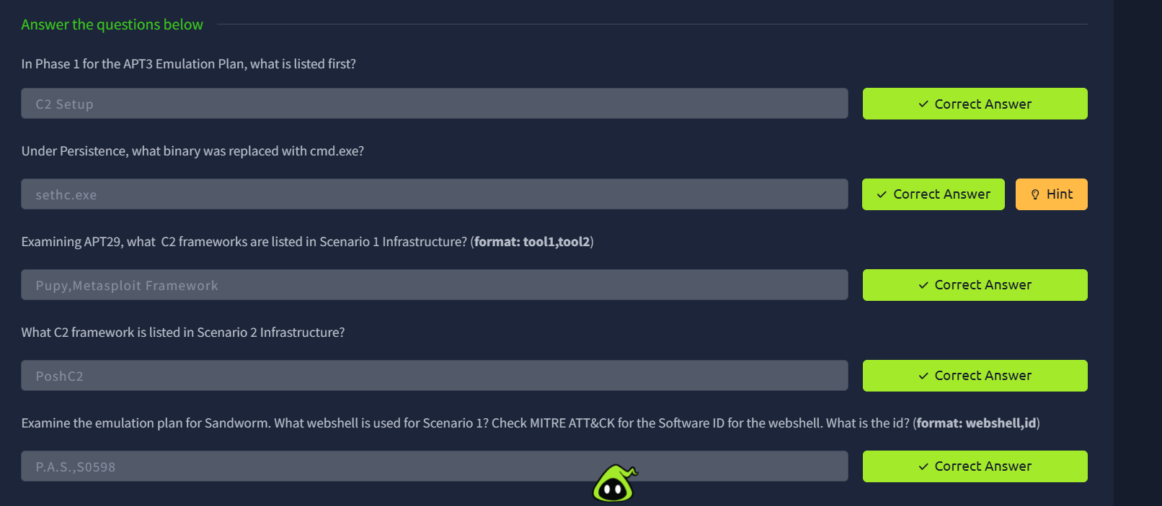

Attack and Threat Intelligence:
Threat intelligence and CTI cyber threat intelligence are the dedicated teams with in the large organization to provide the information about the threat intelligence and the attacks that are top-trending now a days.

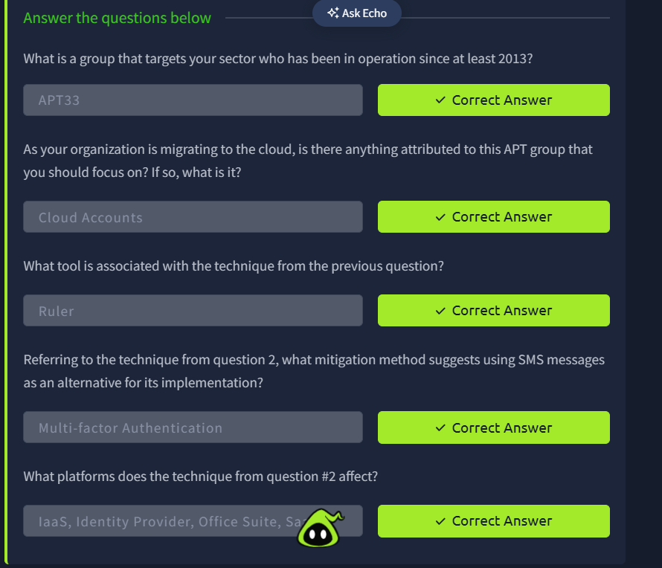

Conclusions:
Overall the MITRE frame works along its various domains like Att&ck , D3FEDN, Engage , CAR , AEP. Is a very grateful for mapping the theoretical concept to overall actionable steps of Adversary.

